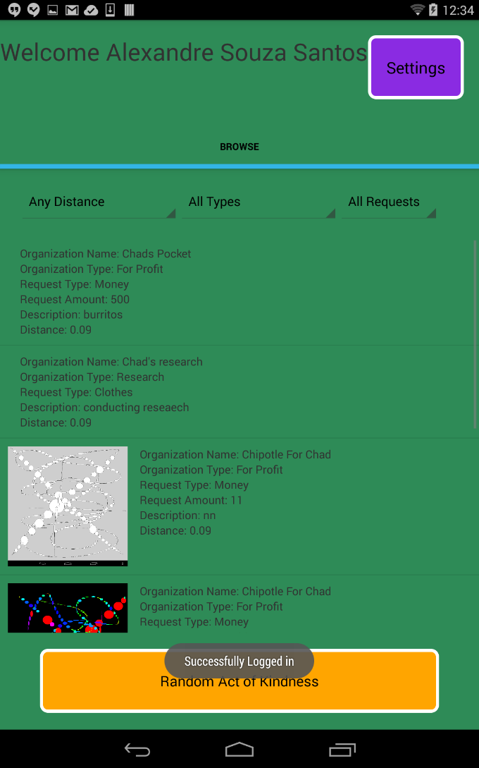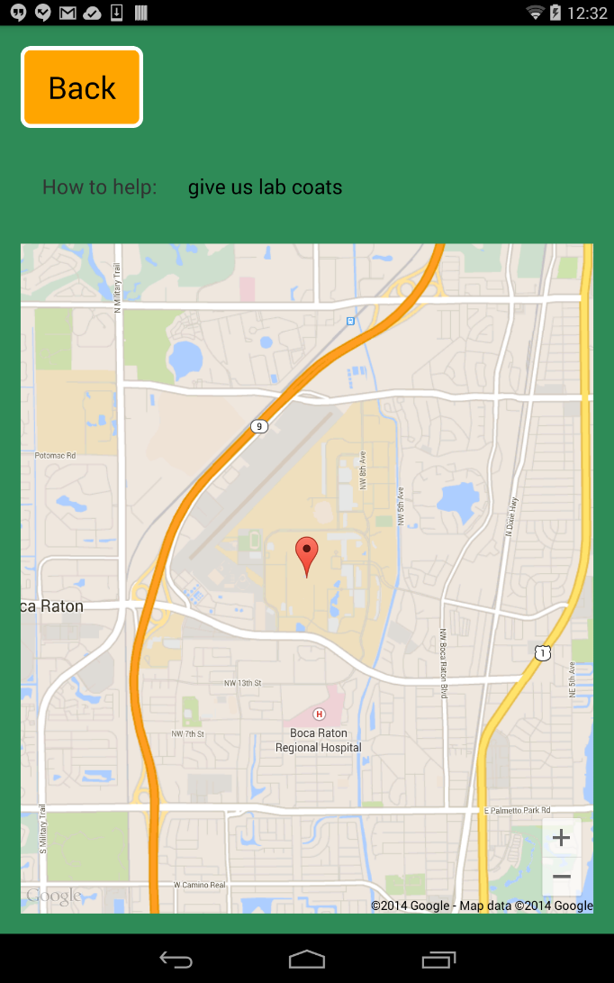

Our application used Parse and the Google Maps API v2 to implement the biggest part of our app. User and organization accounts are stored to the Parse database when a successful sign up occurs. Accounts are handled and validated by the Parse database. Events use both the Parse database as well as the Google Maps API. If an event is a non monetary request, then the app will send the gps location of the event to the database and when the event is browsed, a map of the current event is shown. When you go to the browse page, Parse is queried and events are dynamically populated on the users screen.